**DESIGNING A SALES DASHBOARD IN EXCEL**

Filed by

JAGADEESWARAN A B

(Business Analyst)

Simplilearn EXCEL project I

**PROJECT DESCRIPTION**

Use Excel to analyse the sales based on various product categories.

**Tasks to be performed in Excel:**

* Use the saved Sample E-Commerce database
* Prepare a table of Sales and Profit month-wise in a working sheet
* Prepare the sales table region-wise in the working sheet
* Create User Control Combo box for Product Category
* Create a Column Chart of the month-wise table and region-wise table
* Link the table with a combo box
* Create a dashboard.

**Tools required:**

Microsoft Excel, Data Analysis Add-in

**Expected Deliverables:**

Design a sales dashboard that analyses the sales based on various product categories.

The company wants to add user control for product category so that users can select a category and can see the trend month-wise and product-wise accordingly.

**Sales dashboard using EXCEL - step-by-step process**

* Saved e-commerce dataset from the simplilearn portal
* Created new worksheets for Working space and Dashboard
* Changed name for the entire column in Name Box for the columns Region, Profit, Product category, Sales and months in sales data
* Created sales dashboard sheet with combo boxes for product category, Month and region

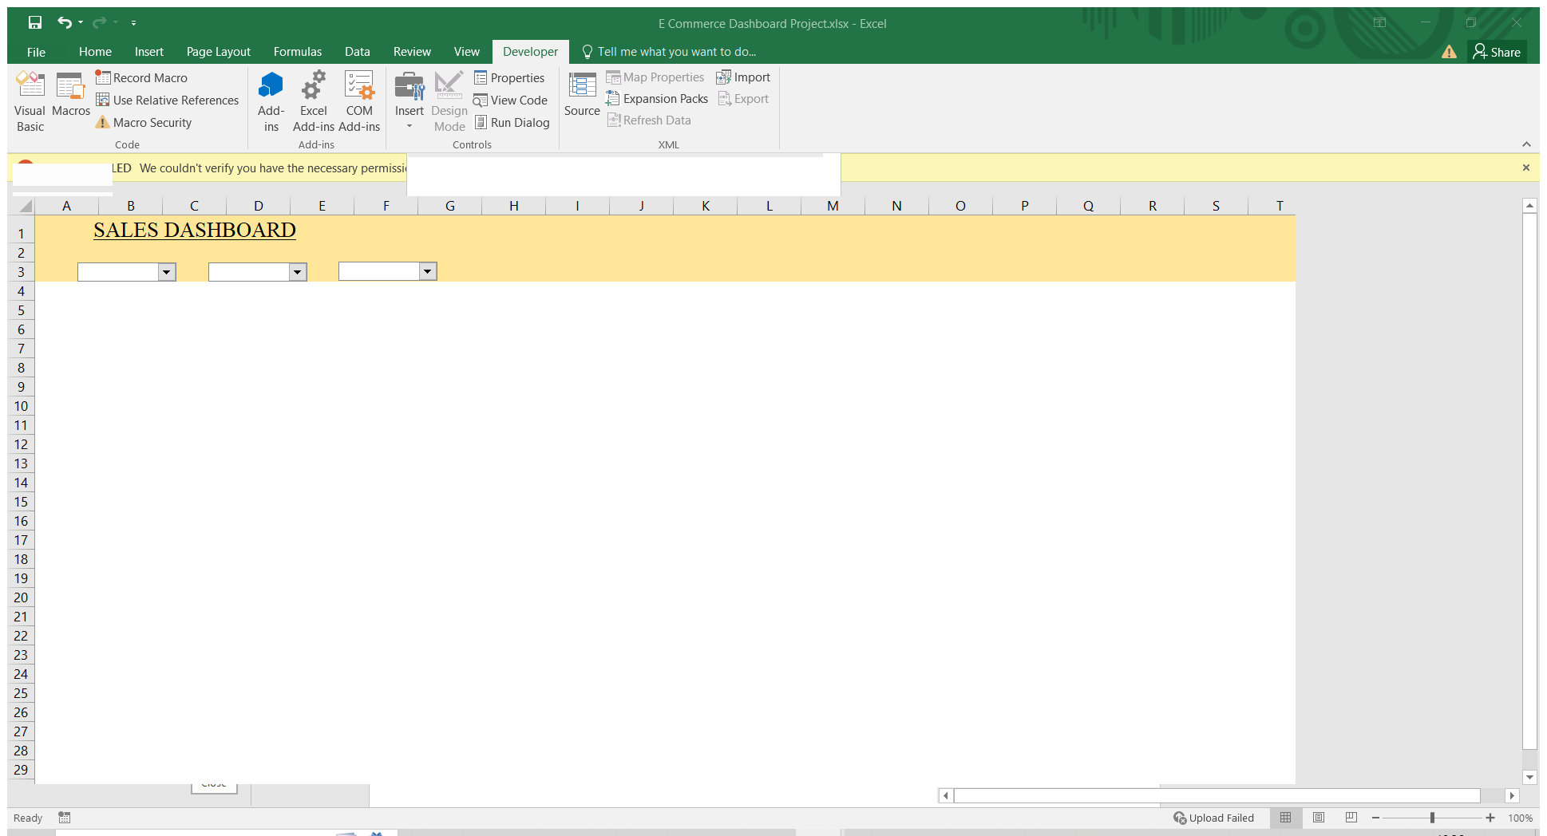

* Created tables which are needed to create dashboard in a working sheet

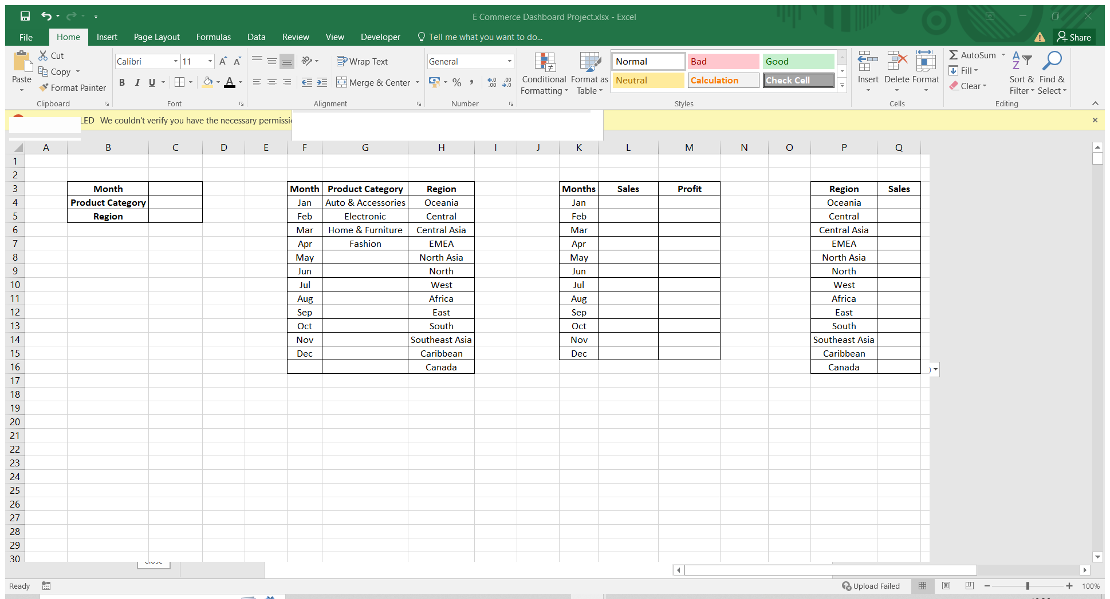

* Format region, month and product category combo box using format control option

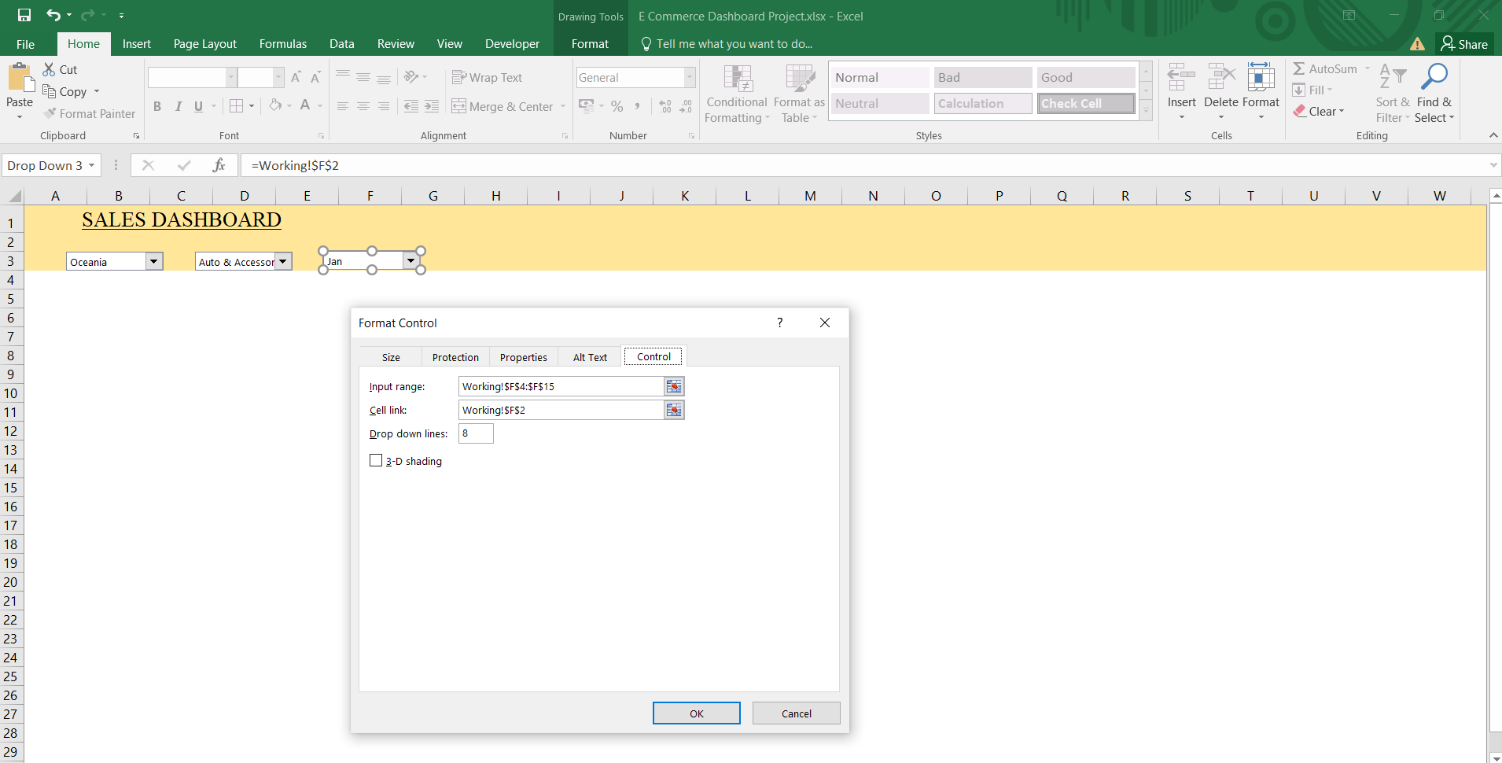

**Formulas used to form the tables**

Formulas :

=INDEX($F$4:$F$15,$F$2)

=index($G$4:$G$7,$G$2)

=INDEX($H$4:$H$16,$H$2)

Result :



Formulas :

=SUMIFS(sales,Region,$C$5,Productcategory,$C$4,Months,K4)

=SUMIFS(Profit,Region,$C$5,Productcategory,$C$4,Months,K4)

Result :



Formulas :

=SUMIFS(sales,Region,P4,Productcategory,$C$4,Months,$C$3)

=SUMIFS(profit,Region,P4,Productcategory,$C$4,Months,$C$3)

Result :



Formulas :

=SUMIFS(sales,Months,$C$3,Region,$C$5,Productcategory,C19)

=SUMIFS(Profit,Months,$C$3,Region,$C$5,Productcategory,C19)

Result :



* Completed all the required table using above formulas

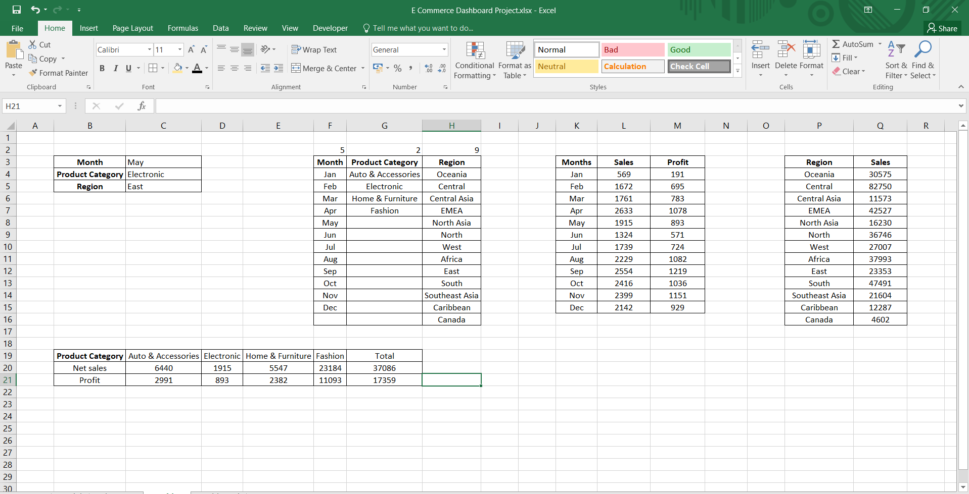

* Created month wise breakdown of net sales and profit using data’s in month wise table

 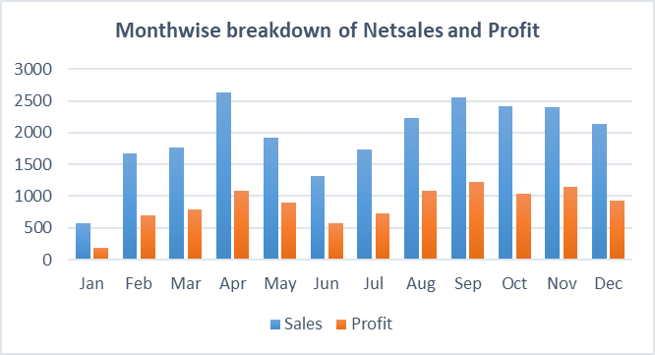

* Formed stacked bar chart with category wise net sales data



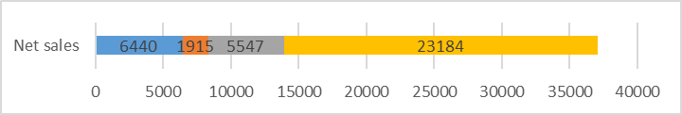

* Created sales chart by region wise breakdown

 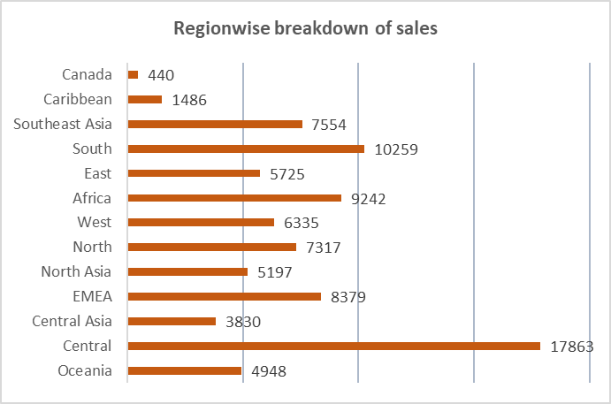

* Created a pie chart which shows the percentage of sales based on product category



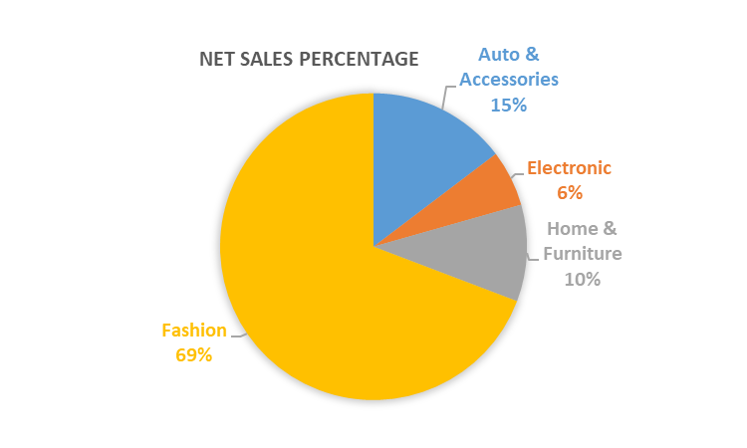

* Created line chart fro profit with region wise data



* By using all the above charts final sales dashboard was created

**DASHBOARD**

